July 25, 2013

Dear Doctor:
Because you are a dedicated professional in the specialty, it gives us great personal pleasure to invite you to join the Otolaryngology Historical Society (OHS).
Our society, a section of the AAO-HNS Foundation, provides a forum where OHS members can discuss, present, and safeguard the history of otolaryngology in all its aspects.
Sign up today for only $50 annually to help continue our specialty’s legacy. You will join a special group of otolaryngologists, who share a passion for preserving the valuable contributions to the specialty throughout the years.
As an OHS member, you receive a complimentary ticket for our OHS annual event held during the AAO-HNSF Annual Meeting & OTO EXPO.
Date: Monday, September 30, 2013
Time: 6:30 pm-8:30 pm
Place: Vancouver Club Club 915 West Hastings St, Vancouver V6C FC6, BC, Canada
Room: Bar Room Three

At this informal social gathering, papers are presented on select topics, related to the history of the specialty, including
- leading pioneers (Avicenna, Pulitzer, Chevalier Jackson)
- anatomical discoveries (Zenker’s Diverticulum, Eustachian tube)
- famous patients (Kaiser Frederick II, Constantine Paddleford, Ulysses S. Grant)
- evolution of surgical techniques (laryngectomy, pediatric airway, tonsillectomy, tympanostomy)
- various countries (Byzantine, Israeli)
- miscellaneous (otolaryngology in art, tobacco advertizing)
- department histories that shed light on new surgical techniques or discoveries

We look forward to welcoming you as an OHS member at our 2013 meeting September 30, 6:30 pm-8:30 pm in Vancouver, BC, Canada for a fascinating and enjoyable evening.
Kind regards and many thanks,
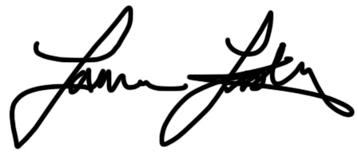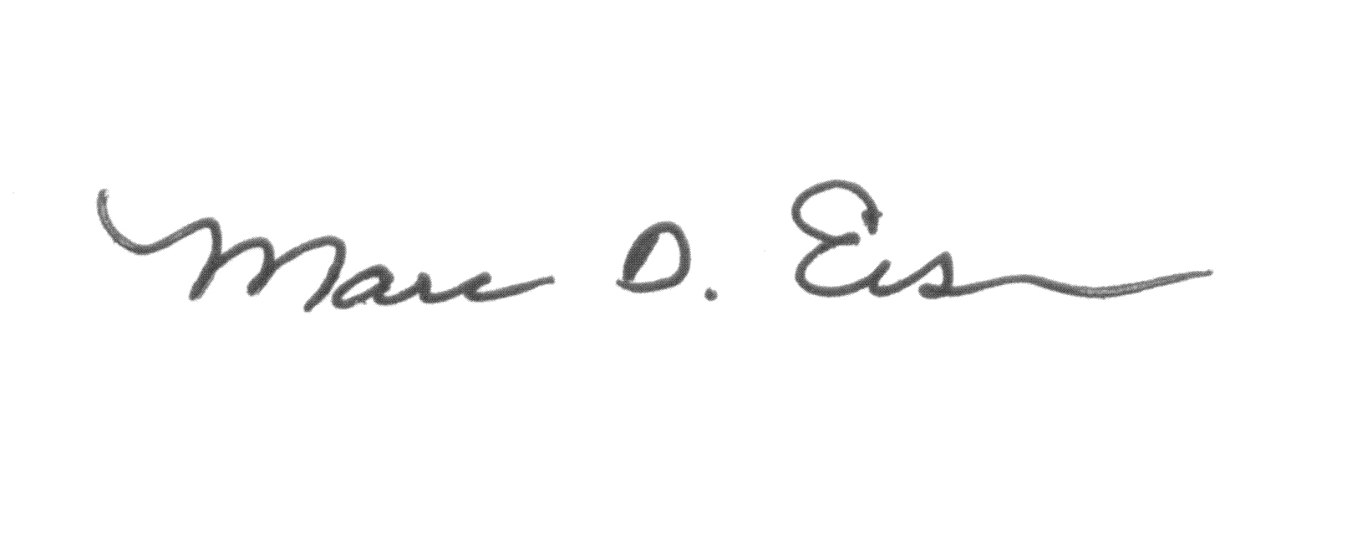
Lawrence R. Lustig, MD Marc R Eisen, MD, PhD
Chair President,
AAO-HNSF History & Archives Committee Otolaryngology Historical Society (OHS)

P. S. To learn more, contact memberservices@entnet.org, or call the number shown below.

OHS DUES PAYMENT FORM
AAO-HNS ID #:
[ ] Yes! I want to join the OHS for $50.00. Enclosed is my payment for the annual dues.
Please return your completed form with payment to AAO-HNS before September 30th, 2013.
Four easy ways to join OHS!
Mail: AAO-HNS, 1650 Diagonal Road, Alexandria, VA 22314-2857
Phone: Toll-free 1-877-722-6467 (US and Canada); 1-703-836-4444 (international)
Fax: 1-703-684-4288
Scan and email to memberservices@entnet.org
The Academy accepts checks, credit card payments, and money orders. All checks must be in U.S. dollars drawn on a U.S. bank and made payable to: AAO-HNS.
Member ID #
Members Name:
Payment Method: _____Check _____Credit Card _____
Check No. ____________________
Credit Card: VISA MasterCard AMEX
Credit Card #

Credit Card Expiration Date: / Security #
Name as it appears on Credit Card:
Amount: $ Authorization #: Batch #:
Processed By (AAO-HNS Staff): Date: _____________________
Mail to Attn. Member Services, AAO-HNS, 1650 Diagonal Road, Alexandria, VA 22314-2857

