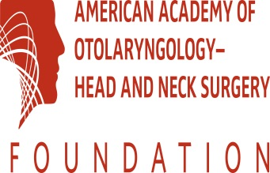
Join Our Regional Advisors at the Latest International Symposium
“Global Health 2014: Our Academy around the World”
Sponsored by the International Steering Committee
Tuesday, September 22, 2014 10:30 am—11:50 am
Orange County Convention Center, Room West 206
This international symposium will showcase Academy relationships and activities in six regions of the world. President Richard W. Waguespack will describe his vision for enhanced international collaboration.
- Welcome by James E. Saunders, MD, Coordinator for International Affairs

- Greetings from Richard W. Waguespack, MD, President

- Introduced by Soha N. Ghossaini, MD, Regional Advisor for the Middle East
Abdulrahman Abdullah Al-Hagr, MBBS, FRCSC, Saudi Arabia
“Future of deafness in Saudi Arabia”
- Introduced by David W. Kennedy, MD, Regional Advisor for Europe
David J. Howard, FRCS, FRCSEd, United Kingdom
“ENT/Head and neck surgery in West Africa”
- Introduced by Ramon A. Franco, MD
Freddy A. Ferreras, MD, Dominican Republic
“Current situation of ENT services in the Dominican Republic”
- Introduced by KJ Lee, MD, Regional Advisor for the Pacific Rim
Dato Lokman Saim, MD, FRCS, Malaysia
“Ear care in ASEAN countries: challenges and changes”
- Introduced by Eugene N. Myers, MD, FRCS Ed Hon, Regional Advisor, International Steering Committee
Jan Betka, MD, PhD, Czech Republic
“The health system and otorhinolaryngology service in Central Europe"
- Introduced by Pablo Stolovitzky, MD, Regional Advisor for Latin America
Jose Julio Letort, MD, Ecuador
“Ear problems in underprivileged people in Ecuador”

- Thanks from Gayle E. Woodson, MD, President-elect

At the conclusion, President-elect Gayle E. Woodson, MD, Dr. Saunders, and the Regional Advisors will present certificates of appreciation designating the visiting speakers as “American Academy goodwill ambassadors,” who will bring the message of mutual collaboration to their own countries and regions, together working for the best ear, nose, and throat care worldwide.
We look forward to welcoming you to the Global Otolaryngology 2015!

