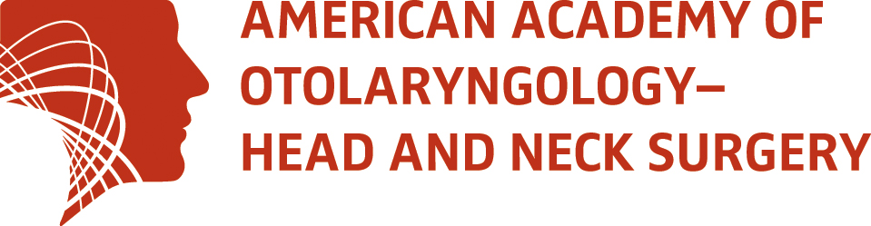

2017 Committee Excellence Award

The Committee Excellence Award recognizes committees that contribute in ways that lead to the overall success of the AAO-HNS/F mission: empowering otolaryngologist—head and neck surgeons to deliver the best patient care. These committees have a passion for the AAO-HNS/F’s visions and for accomplishing and enhancing the activities outlined in the AAO-HNS/F strategic plan.

Committees that meet the following criteria may apply to be considered for a Committee Excellence Award:

- effective committee chair leadership;
- responsive, engaged and active committee members who have a desire to volunteer time and resources;
- responsive to and regularly participate in AAO-HNS/F surveys;
- have a well-articulated charge and supporting work plan that is aligned with and supports the AAO-HNS/F Strategic Plan;
- work plan is revised annually and achieved within the established timeline.

Some examples of committee work products that meet Committee Excellence Award criteria include:

- Represent the Academy to external organizations related to ENT and to medicine; for example, communicating AAO-HNS/F initiatives to members, the public, and the house of medicine.
- Monitor and apprise the Executive Committee and staff through reports, the website, and news/scientific publications.
- Help build evidence-based research and conduct research that leads to new clinical guidelines, performance measures, quality improvement tools, and advancements in payment.
- Create products that educate physicians, allied health professionals, and patients; for example, participating at the annual meeting, creating content for AcademyU®, identifying curriculum for MOC or imaging in otolaryngology, or developing/revising patient information materials.
- Facilitate market research and business intelligence about otolaryngology's environment through surveys; for example, a patient safety survey, surveys about clinical topics, or opinion surveys about new products/services.
- Collaborate with specialty societies on topics of mutual interest.
- Participate in RUC surveys and help facilitate participation in RUC by others.
- A committee work plan that supports and potentiates the AAO-HNS/F Strategic Plan.

The award is based on activities from October 1, 2016 through September 30, 2017 and will be
recognized at the 2017 Annual Meeting & OTO Experience in Chicago, Illinois.
2017 Committee Excellence Award Application

Committee Name: __________________________________________________________
Nominated By: _____________________________________________________________

Relationship to Committee: ___________________________________________________
Email: _________________________

Please take as much space as needed to complete your responses to all questions.

- Why do you believe this committee is worthy of a Committee Excellence Award?

- How has this committee contributed to the success of the AAO-HNS/F mission (site specific examples)?

- In what specific ways has this committee met some, or all, of the following criteria?
- effective committee chair leadership;
- responsive, engaged and active committee members who have a desire to volunteer time and resources;
- responsive to and regularly participate in AAO-HNS/F surveys;
- have a well-articulated charge and supporting work plan that is aligned with and supports the AAO-HNS/F Strategic Plan;
- work plan is revised annually and achieved within the established timeline.

- Does the nominated committee provide a forum for members to share ideas, progress, and facilitate shared communications?
Yes No
If “Yes,” please explain and site specific examples.

Applications must be received no later than Thursday, June 1, 2017 either by mail to the address below, email to committees@entnet.org, or fax to 1-703-535-8584.

AAO-HNS
Attn: Committees
1650 Diagonal Road
Alexandria, VA 22314-2857

