Hal Foster, MD Endowment – Campaign History
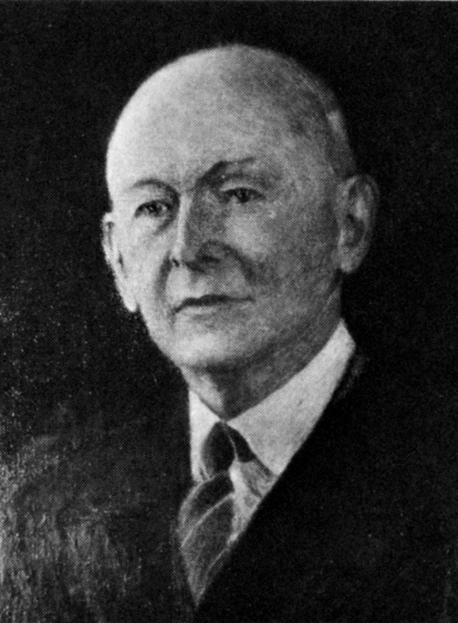
“We are still trying to make people see and hear. May this high scientific work continue and future generations yet unborn profit thereby” - Hal Lovelace Foster, MD, founder of the AAO-HNS

AAO-HNS foundation’s first-ever endowment campaign was established in 2012 in honor of Dr. Hal Lovelace Foster.

In 1896, Dr. Hal Lovelace Foster called the first meeting of what would later become the AAO-HNS. He invited more than 500 ophthalmologists and otolaryngologists to assemble together for the first time.
Dr. Foster had the insight to understand the importance of creating a forum to advance professional learning for the benefit of quality patient care in the specialty. And this commitment was a personal one. Foster paid for the cost of that meeting – an estimated $400 – himself. He said of that first meeting, “the money I spent in calling those specialists together was the best investment I ever made.”
This is the first-ever endowment campaign that the AAO-HNS and AAO-HNSF have embarked upon. As such, it is fitting to pay tribute to the man who created this organization by naming the campaign in his honor.
Dr. Foster demonstrated incredible generosity and leadership that resulted in the creation of AAO-HNSF, the largest organization representing today’s otolaryngologist –head and neck surgeons.
He inspires all of us who are beneficiaries of his legacy to make the same choice of providing leadership level philanthropy, and the opportunity to invest in the future of our profession.

